| CSE 308: Digital System Design | Homework 3 Solution |

Problem 1: Draw the synthesized circuits described by the Verilog codes below. (a)

module FA (a, b, cin, cout, sum);

input a, b, cin; //inputs

output cout, sum; //outputs

wire w1, w2, w3, w4; // internal nets

xor #(10) (w1, a, b); //delay time of 10 units

xor #(10) (sum, w1, cin);

and #(8) (w2, a, b); //delay time of 8 units

and #(8) (w3, a, cin);

and #(8) (w4, b, cin);

or #(10)(cout, w2, w3, w4);

endmodule

Solution:

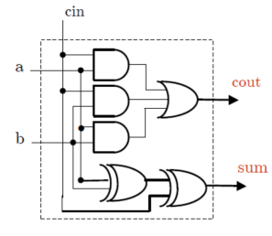

(b)

module smpl_circuit (A, B, C, x, y); input A, B, C;

output x, y;

wire e;

and #(10) g1(e, A, B);

not #(5) g2(y, C);

or #(15) g3(x, e, y);

endmodule

Solution:

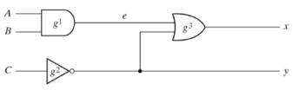(c)

module D_latch (D, Clk, Q);

input D, Clk;

output Q;

reg Q;

always @(D or posedge Clk)

if (Clk)

Q = D;

endmodule

Solution:

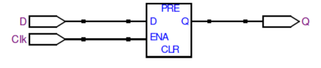

Problem 2: Implement an 8-bit ripple carry adder, using as building block the 1-bit full adder from 1(a). Use the following module template for your top level design:

module adder8 (A, B, cin, S, cout);

input[7:0] A, B;

input cin;

output[7:0] S;

output cout;

wire c1, c2, c3, c4, c5, c6, c7;

//place code here

endmodule

Solution:

module adder8 (A, B, cin, S, cout);

input[7:0] A, B;

input cin;

output[7:0] S;

output cout;

wire c1, c2, c3, c4, c5, c6, c7;

//place code here

//8 instantiated 1-bit Full Adders

FA fa0(A[0], B[0], cin, c1, S[0]);

FA fa1(A[1], B[1], c1, c2, S[1]);

FA fa2(A[2], B[2], c2, c3, S[2]);

FA fa3(A[3], B[3], c3, c4, S[3]);

FA fa4(A[4], B[4], c4, c5, S[4]);

FA fa5(A[5], B[5], c5, c6, S[5]);

FA fa6(A[6], B[6], c6, c7, S[6]);

FA fa7(A[7], B[7], c7, cout, S[7]);

endmodule

Problem 3: Implement a 4-bit magnitude comparator using dataflow description (i.e. using continues assignment). Here’s the skeleton of the module.

module mag_comp4 (A, B, ALB, AGB, AEB);

input [3:0] A,B;

output ALB, AGB, AEB;

//ALB 🡪 A<B, AGB 🡪 A>B, AEB 🡪 A=B

//place code here

endmodule

Solution:

module mag_comp (A, B, ALB, AGB, AEB);

input [3:0] A, B;

output ALB, AGB, AEB;

//ALB 🡪 A<B, AGB 🡪 A>B, AEB 🡪 A=B

//place code here

assign ALB = (A<B), AGB = (A>B), AEB = (A==B);

endmodule

Problem 4: The following code is intended to implement a 1:2 de-MUX. The input is x and two outputs are y and z, and the switch control is s.

**wire x, y;**

**reg z;**

**always @(x or y or z)**

**begin**

**if (!s) y=x;**

**else z=x;**

**end**

(a) Find out all things wrong in this code.

Solution:

⎯ y has to be defined as reg

⎯ y and z must not be in the trigger list

⎯ s must be in the sentivity list

(b) Does the code produce any latches? If no, state why. If yes, how many latches can be produced? And by which statement(s)?

Solution:

⎯ Yes. 2 latches

⎯ One to store previous value of z, when s = 0 (y = x).

⎯ One to store previous value of y, when s = 1 (z = x).

(c) After all problems you find in (a) are fixed, draw the logic diagram of the synthesized hardware from the corrected code.

Solution:

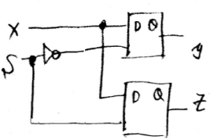

Problem 5: Below is a short snippet of Verilog code of a digital functional block. Draw the logic circuit diagram that is described by the Verilog code.

module M (Q, S, A, B, C);

output Q;

input S, A, B, C;

reg Q;

always @(posedge C) Q = (S) ? A : B ;

endmodule;

Solution:

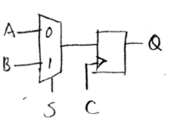

Problem 6: In this problem, design a 3-bit gray counter with positive reset. When reset, the count value becomes 000. Recall that a gray counter changes only one bit at a time. For example, a 2-bit gray counter has a count sequence 00, 01, 11, 10 corresponding to decimal count values of 0, 1, 2, and 3 respectively. In the gray count sequence, only one bit changes between adjacent count values, and the right most bit is changed as long as it does not result in a code word that has been visited earlier.

The following are the ports of the module:

C 1-bit clock input, all actions must be on the positive edge R 1-bit reset, causes reset on the positive edge

OUT 3-bit result

Solution:

**module GRAY_CNT (**

**C,**

**R,**

**OUT);**

**input C;**

**input R;**

**output [2:0] OUT;**

**reg [2:0] OUT;**

**always @ (posedge C)**

**if (R)**

**OUT = 3'b000;**

**else**

**case (OUT)**

**3'h0: OUT = 3'h1;**

**3'h1: OUT = 3'h3;**

**3'h3: OUT = 3'h2;**

**3'h2: OUT = 3'h6;**

**3'h6: OUT = 3'h7;**

**3'h7: OUT = 3'h5;**

**3'h5: OUT = 3'h4;**

**3'h4: OUT = 3'h0;**

**default: OUT = 3'h0;**

**endcase**

**endmodule**

Problem 7: In this module, create a byte-wide 8-to-1 multiplexer. In this case, the value on the 3-bit select line will route 1 of 8 inputs to the output. This module is purely combinatorial.

The following are the ports of the module:

S 3-bit select line

I0, I1, I2, I3, I4, I5, I6, and I7 8-bit data inputs O 8-bit output

Solution:

**module MUX_8 (**

**S,**

**I0,**

**I1,**

**I2,**

**I3,**

**I4,**

**I5,**

**I6,**

**I7,**

**O);**

**input [2:0] S;**

**input [7:0] I0;**

**input [7:0] I1;**

**input [7:0] I2;**

**input [7:0] I3;**

**input [7:0] I4;**

**input [7:0] I5;**

**input [7:0] I6;**

**input [7:0] I7;**

**output [7:0] O;**

**reg O;**

**always @ (*)**

**case (S)**

**3’b000: O = I0;**

**3’b001: O = I1;**

**3’b010: O = I2;**

**3’b011: O = I3;**

**3’b100: O = I4;**

**3’b101: O = I5;**

**3’b110: O = I6;**

**3’b111: O = I7;**

**endcase**

**endmodule**

Problem 8: For this design, combine gray counter (from Problem 6) with the multiplexer (from Problem 7) to create a circuit such that the output of the gray counter controls the select lines of the multiplexer.

The top-level design has the following port definitions:

C 1-bit clock

R 1-bit reset line

D0, D1, D2, D3, D4, D5, D6, and D7 8-bit data inputs OUT 8-bit data output

Solution:

**module TOP (**

**C,**

**R,**

**OUT,**

**D0,**

**D1,**

**D2,**

**D3,**

**D4,**

**D5,**

**D6,**

**D7);**

**input C, R;**

**input [7:0] D0;**

**input [7:0] D1;**

**input [7:0] D2;**

**input [7:0] D3;**

**input [7:0] D4;**

**input [7:0] D5;**

**input [7:0] D6;**

**input [7:0] D7;**

**output [7:0] OUT;**

**wire [7:0] GRAYOUT;**

**GRAY_CNT GRAYCNT_INST1 (C, R, GRAYOUT);**

**MUX_8 MUX8_INST1 (GRAYOUT, D0, D1, D2, D3, D4, D5, D6, D7, OUT);**

**endmodule**